Framework Explanation

Pre-requisites- Please **install testng** on your Eclipse ide.

Script Run: Please run the scripts present in **Com.seleniumscript package.**

**User_Test_Erail.java** >>Right click and run as Java Application

**User_Test_OrangeHRM.java**>> Right click and run as TestNg test.(Used testNg for dynamic overview).

The automation framework that I have created is a **maven project** and all the dependencies are managed in **pom.xml.**

We are using Maven for managing the external dependencies like Selenium, testng, extentreports WebDriver and others.

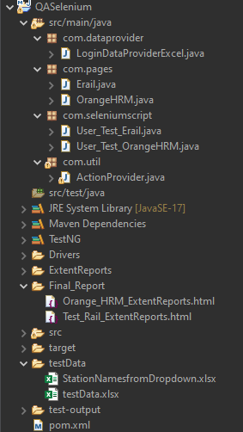

1. **Page Object Model**

I have used Page Object Model for the framework. The page classes are present under the com.pages package

1. **Com.seleniumscript**

The scripts are present in the com.seleniumscript where we are running the tests using main method and Testng. All Page Methods written in the Page Objects and ActionProvider util methods are called in the scripts.

1. **Com.util**

All selenium functions are wrapped under special wrapper functions. These wrapper functions create abstraction in our framework. ActionProvider is a class which contains these wrapper function which consist selenium and other utility methods.

1. **Final Folder**

Final Test Reports are kept in **Final_Report** generated by Extent Report.

1. **TestData**

The testData folder contains the excel file from which we are getting testdata for the login credentials and storing the station values to compare.

1. **Com.DataProvider**

The dataprovider class is used to send multiple login credentials from the excel sheet for the OrangeHRM login functionality.

1. **Test Data Files**

* **Testdata.xlsx** – Contains Username and Password for OrangeHRM login Functionality. Where First 2 Entries contains Incorrect password and with 3rd Entry, we are able to login to the application.
* **StationNamesFromDropdown.xlsx** – It Contains 2 Sheets. In First sheet we writing 10 Station names in our Excel and in 2nd we have Expected Stations with which we are comparing our Actual Stations Printed in Sheet 1